What is Computer Architecture?

**Computer Architecture** is a blueprint for design and implementation of a computer system. It refers to the overall design of a computer system, including the hardware and software components that make up the system and how they interact with each other.

Computer architecture provides the functional details and behavior of a computer system. It involves the design of the instruction set, the microarchitecture, and the memory hierarchy, as well as the design of the hardware and software components that make up the system.

Computer Architecture mainly deals with the functional behavior of a computer system and covers the "What to do?" part. It gives the functional description of requirements, design, and implementation of the different parts of a computer system.

In the designing process of a computer system, the computer architecture is to be defined before the computer organization.

What is Computer Organization?

**Computer Organization** refers to the way in which the hardware components of a computer system are arranged and interconnected. It implements the provided computer architecture and covers the "How to do?" part.

[**Computer Organization**](https://www.tutorialspoint.com/Computer-System-Organisation) is to be defined after the decision of the computer architecture. It just provides information that how operational attributes of a computer system are linked together and help in realizing the architectural specification of the computer. It involves the design of the interconnections between the various hardware components, as well as the design of the memory and I/O systems.

Differences between Computer Architecture and Computer Organization

The following table highlights how Computer Architecture is different from Computer Organization

|  |  |  |
| --- | --- | --- |
| **Key** | **Computer Architecture** | **Computer Organization** |
| Purpose | Computer architecture explains what a computer should do. | Computer organization explains how a computer works. |
| Target | Computer architecture provides functional behavior of computer system. | Computer organization provides structural relationships between parts of computer system. |
| Design | Computer architecture deals with high level design. | Computer organization deals with low level design. |
| Role | Computer architecture assists in understanding the functionality of the computer. | Computer organization helps to understand the exact arrangement of component of a computer. |
| Actors | Actors in Computer architecture are hardware parts. | Actor in computer organization is performance. |
| Order | Computer architecture is designed first. | Computer organization is started after finalizing computer architecture. |
| Involves | Computer architecture involves the relationship among logical attributes of the system like instruction sets, data types, addressing modes, etc. | Computer organization involves the relationship among physical parts of the system like circuits, peripherals, etc. |

In general, Computer Architecture is concerned with the overall design of a computer system, while Computer Organization is concerned with the way in which the hardware components of the system are arranged and interconnected.

**The most important point that you should note here is that Computer Architecture explains what a computer should do, whereas Computer Organization explains how a computer works.**

# **GENERATIONS OF A COMPUTER**

Generation in computer terminology is a change in technology a computer is/was being used. Initially, the generation term was used to distinguish between varying hardware technologies. But nowadays, generation includes both hardware and software, which together make up an entire computer system.

There are totally five computer generations known till date. Each generation has been discussed in detail along with their time period and characteristics. Here approximate dates against each generations have been mentioned which are normally accepted. Following are the main five generations of computers

|  |  |
| --- | --- |
| **S.N.** | **Generation & Description** |
| 1 | [**First Generation**](https://www.tutorialspoint.com/computer_fundamentals/computer_first_generation.htm)  The period of first generation: 1946-1959. Vacuum tube based. |
| 2 | [**Second Generation**](https://www.tutorialspoint.com/computer_fundamentals/computer_second_generation.htm)  The period of second generation: 1959-1965. Transistor based. |
| 3 | [**Third Generation**](https://www.tutorialspoint.com/computer_fundamentals/computer_third_generation.htm)  The period of third generation: 1965-1971. Integrated Circuit based. |
| 4 | [**Fourth Generation**](https://www.tutorialspoint.com/computer_fundamentals/computer_fourth_generation.htm)  The period of fourth generation: 1971-1980. VLSI microprocessor based. |
| 5 | [**Fifth Generation**](https://www.tutorialspoint.com/computer_fundamentals/computer_fifth_generation.htm)  The period of fifth generation: 1980-onwards. ULSI microprocessor based |

## First generation

The period of first generation was 1946-1959. The computers of first generation used vacuum tubes as the basic components for memory and circuitry for CPU (Central Processing Unit). These tubes, like electric bulbs, produced a lot of heat and were prone to frequent fusing of the installations, therefore, were very expensive and could be afforded only by very large organizations. In this generation mainly batch processing operating system were used. Punched cards, paper tape, and magnetic tape were used as input and output devices. The computers in this generation used machine code as programming language.

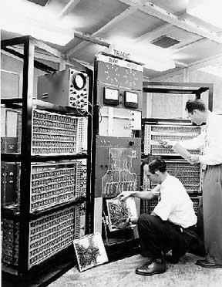

The main features of first generation are:

* Vacuum tube technology
* Unreliable
* Supported machine language only
* Very costly
* Generated lot of heat
* Slow input and output devices
* Huge size
* Need of A.C.
* Non-portable
* Consumed lot of electricity

Some computers of this generation were:

* ENIAC
* EDVAC
* UNIVAC
* IBM-701
* IBM-650

## Second generation

The period of second generation was 1959-1965. In this generation transistors were used that were cheaper, consumed less power, more compact in size, more reliable and faster than the first generation machines made of vacuum tubes. In this generation, magnetic cores were used as primary memory and magnetic tape and magnetic disks as secondary storage devices. In this generation assembly language and high-level programming languages like FORTRAN, COBOL were used. The computers used batch processing and multiprogramming operating system.

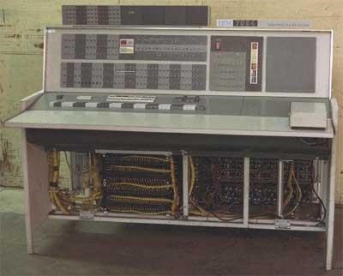

The main features of second generation are:

* Use of transistors
* Reliable in comparison to first generation computers
* Smaller size as compared to first generation computers
* Generated less heat as compared to first generation computers
* Consumed less electricity as compared to first generation computers
* Faster than first generation computers
* Still very costly
* A.C. needed
* Supported machine and assembly languages Some computers of this generation were:
* IBM 1620
* IBM 7094
* CDC 1604
* CDC 3600
* UNIVAC 1108

## Third generation

The period of third generation was 1965-1971. The computers of third generation used integrated circuits (IC's) in place of transistors. A single IC has many transistors, resistors and capacitors along with the associated circuitry. The IC was invented by **Jack Kilby**. This development made computers smaller in size, reliable and efficient. In this generation remote processing, time-sharing, multi-programming operating system were used. High level languages (FORTRAN-II TO IV, COBOL, PASCAL PL/1, BASIC, ALGOL-68 etc.) were used during this generation.

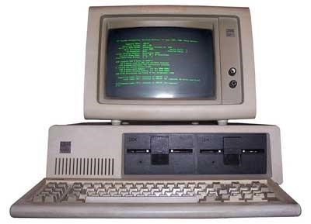

The main features of third generation are:

* IC used
* More reliable in comparison to previous two generations
* Smaller size
* Generated less heat
* Faster
* Lesser maintenance
* Still costly
* A.C needed
* Consumed lesser electricity
* Supported high-level language

Some computers of this generation were:

* IBM-360 series
* Honeywell-6000 series
* PDP(Personal Data Processor)
* IBM-370/168
* TDC-316

## Fourth generation

The period of fourth generation was 1971-1980. The computers of fourth generation used Very Large Scale Integrated (VLSI) circuits. VLSI circuits having about 5000 transistors and other circuit elements and their associated circuits on a single chip made it possible to have microcomputers of fourth generation. Fourth generation computers became more powerful, compact, reliable, and affordable. As a result, it gave rise to personal computer (PC) revolution. In this generation time sharing, real time, networks, distributed operating system were used. All the high-level languages like C, C++, DBASE etc., were used in this generation.

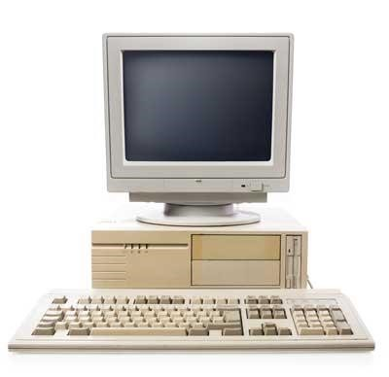

The main features of fourth generation are:

* VLSI technology used
* Very cheap
* Portable and reliable
* Use of PC's
* Very small size
* Pipeline processing
* No A.C. needed
* Concept of internet was introduced
* Great developments in the fields of networks
* Computers became easily available Some computers of this generation were:
* DEC 10
* STAR 1000
* PDP 11
* CRAY-1(Super Computer)
* CRAY-X-MP(Super Computer)

## Fifth generation

The period of fifth generation is 1980-till date. In the fifth generation, the VLSI technology became ULSI (Ultra Large Scale Integration) technology, resulting in the production of microprocessor chips having ten million electronic components. This generation is based on parallel processing hardware and AI (Artificial Intelligence) software. AI is an emerging branch in computer science, which interprets means and method of making computers think like human beings. All the high-level languages like C and C++, Java, .Net etc., are used in this generation.

AI includes:

* Robotics
* Neural Networks
* Game Playing
* Development of expert systems to make decisions in real life situations.
* Natural language understanding and generation.

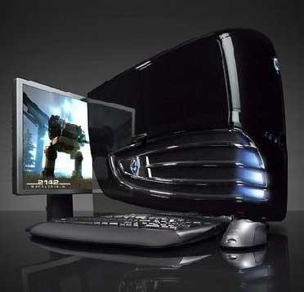

The main features of fifth generation are:

* ULSI technology
* Development of true artificial intelligence
* Development of Natural language processing
* Advancement in Parallel Processing
* Advancement in Superconductor technology
* More user friendly interfaces with multimedia features
* Availability of very powerful and compact computers at cheaper rates Some computer types of this generation are:
* Desktop
* Laptop
* Notebook
* Ultrabook

**COMPUTER TYPES**

**Classification based on Operating Principles**

Based on the operating principles, computers can be classified into one of the following types:

1. Digital Computers
2. Analog Computers
3. Hybrid Computers

**Digital Computers**: - Operate essentially by counting. All quantities are expressed as discrete or numbers. Digital computers are useful for evaluating arithmetic expressions and manipulations of data (such as preparation of bills, ledgers, solution of simultaneous equations etc.).

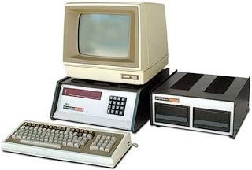

**Analog Computers: -** An **analog computer** is a form of computer that uses the continuously changeable aspects of physical phenomena such as electrical, mechanical, or hydraulic quantities to model the problem being solved. In contrast, digital computers represent varying quantities symbolically, as their numerical values change.

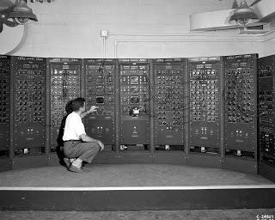

**Hybrid Computers: -** are computers that exhibit features of analog and provide logical operations, while the analog component normally serves as a solver of differential equations.

## Classification digital Computer based on size and Capability

Based on size and capability, computers are broadly classified into

***Micro Computers (Personal Computer)***

A microcomputer is the smallest general purpose processing system. The older pc started 8 bit processor with speed of 3.7MB and current pc 64 bit processor with speed of 4.66 GB.

Examples: - **IBM PC**s, **APPLE** computers

Microcomputer can be classified into 2 types:

1. Desktops
2. Portables

The difference is portables can be used while travelling whereas desktops computers cannot be carried around.

**The different portable computers are: -**

1. Laptop
2. Notebooks
3. Palmtop (hand held)
4. Wearable computers

**Laptop**: - this computer is similar to a desktop computers but the size is smaller. They are expensive than desktop. The weight of laptop is around 3 to 5 kg.

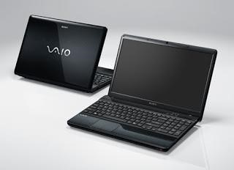

**Notebook**: - These computers are as powerful as desktop but size of these computers are comparatively smaller than laptop and desktop. They weigh 2 to 3 kg. They are more costly than laptop.

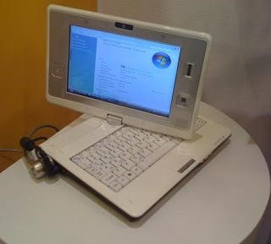

**Palmtop (Hand held)**: - They are also called as Personal Digital Assistant (PDA). These computers are small in size. They can be held in hands. It is capable of doing word processing, spreadsheets and hand writing recognition, game playing, faxing and paging. These computers are not as powerful as desktop computers. Ex: - 3com palm V.

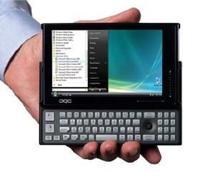

**Wearable computer**: - The size of this computer is very small so that it can be worn on the body. It has smaller processing power. It is used in the field of medicine. For example pace maker to correct the heart beats. Insulin meter to find the levels of insulin in the blood.

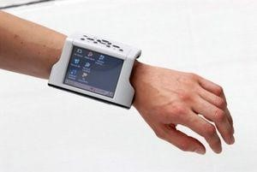

**Workstations: -** It is used in large, high-resolution graphics screen built in network support,

Ex: UNIX and Windows NT.

1. **Minicomputer**: - A minicomputer is a medium-sized computer. That is more powerful than a microcomputer. These computers are usually designed to serve multiple users simultaneously (Parallel Processing). They are more expensive than microcomputers.

Examples: Digital Alpha, Sun Ultra.

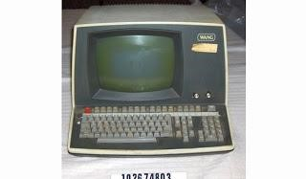

1. **Mainframe (Enterprise) computers**: - Computers with large storage capacities and very high speed of processing (compared to mini- or microcomputers) are known as mainframe computers. They support a large number of terminals for simultaneous use by a number of users like ATM transactions. They are also used as central host computers in distributed data processing system.

Examples: - **IBM 370, S/390.**

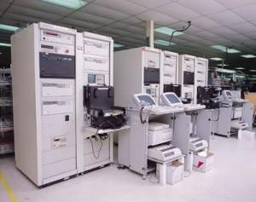

1. **Supercomputer**: - Supercomputers have extremely large storage capacity and computing speeds which are many times faster than other computers. A supercomputer is measured in terms of tens of millions Instructions per second (mi/s), an operation is made up of numerous instructions. The supercomputer is mainly used for large scale numerical problems in scientific and engineering disciplines such as Weather analysis.

Examples: - **IBM Deep Blue**

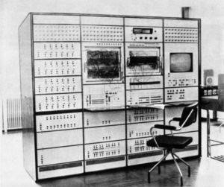

## Classification based on number of microprocessors

Based on the number of microprocessors, computers can be classified into

1. Sequential computers and
2. Parallel computers
3. **Sequential computers**: - Any task complete in sequential computers is with one microcomputer only. Most of the computers (today) we see are sequential computers where in any task is completed sequentially instruction after instruction from the beginning to the end.
4. **Parallel computers**: - The parallel computer is relatively fast. New types of computers that use a large number of processors. The processors perform different tasks independently and simultaneously thus improving the speed of execution of complex programs dramatically.

Parallel computers match the speed of supercomputers at a fraction of the cost.

**Classification based on word-length**

A binary digit is called **“BIT”**. **A word is a group of bits which is fixed for a computer**. The number of bits in a word (or word length) determines the representation of all characters in these many bits. Word length lies in the range from 16-bit to 64-bitsf or most computers of today.

## Classification based on number of users

Based on number of users, computers are classified into: -

**Single User**: - Only one user can use the resource at any time.

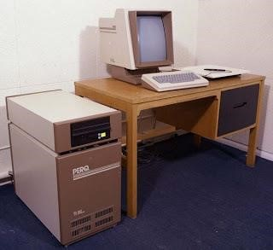

**Multi User**: - A single computer shared by a number of users at any time.

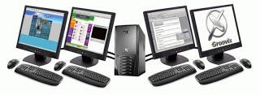

**Network**: - A number of interconnected autonomous computers shared by a number of users at any time.

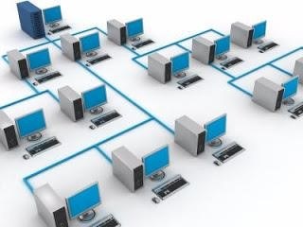

# **COMPUTER TYPES**

A computer can be defined as a fast electronic calculating machine that accepts the (data) digitized input information process it as per the list of internally stored instructions and produces the resulting information. List of instructions are called programs & internal storage is called computer memory.

The different types of computers are

1. **Personal computers: -** This is the most common type found in homes, schools,Business offices etc., It is the most common type of desk top computers with processing and storage units along with various input and output devices.
2. **Note book computers: -** These are compact and portable versions of PC
3. **Work stations: -** These have high resolution input/output (I/O) graphicscapability, but with same dimensions as that of desktop computer. These are used in engineering applications of interactive design work.
4. **Enterprise systems: -** These are used for business data processing in medium tolarge corporations that require much more computing power and storage capacity than work stations. Internet associated with servers has become a dominant worldwide source of all types of information.
5. **Super computers: -** These are used for large scale numerical calculationsrequired in the applications like weather forecasting etc.,

**BASIC TERMINOLOGY**

• Input: Whatever is put into a computer system

• Data: Refers to the symbols that represent facts, objects, or ideas.

• Information: The results of the computer storing data as bits and bytes; the words, umbers, sounds, and graphics.

• Output: Consists of the processed results produced by a computer.

• Processing: Manipulation of the data in many ways.

• Memory: Area of the computer that temporarily holds data waiting to be processed, stored, or output.

• Storage: Area of the computer that holds data on a permanent basis when it is not immediately needed for processing.

• Assembly language program (ALP) –Programs are written using mnemonics

• Mnemonic –Instruction will be in the form of English like form

• Assembler –is a software which converts ALP to MLL (Machine Level Language)

• HLL (High Level Language) –Programs are written using English like statements

• Compiler -Convert HLL to MLL, does this job by reading source program at once

• Interpreter –Converts HLL to MLL, does this job statement by statement

• System software –Program routines which aid the user in the execution of programs e.g.: Assemblers, Compilers

• Operating system –Collection of routines responsible for controlling and coordinating all the activities in a computer system

# **Computers has two kinds of components:**

**Hardware**, consisting of its physical devices (CPU, memory, bus, storage devices ...)

**Software**, consisting of the programs it has (Operating system, applications, utilities ...)

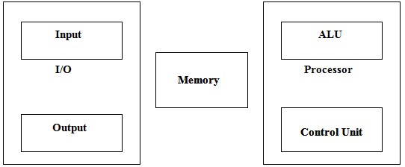

**FUNCTIONAL UNIT**

A computer consists of five functionally independent main parts input, memory,

Arithmetic logic unit (ALU), output and control unit.

Functional units of computer

Input device accepts the coded information as source program i.e. high level language. This is either stored in the memory or immediately used by the processor to perform the desired operations. The program stored in the memory determines the processing steps. Basically the computer converts one source program to an object program. i.e. into machine language.

Finally the results are sent to the outside world through output device. All of these actions are coordinated by the control unit. ­­­­

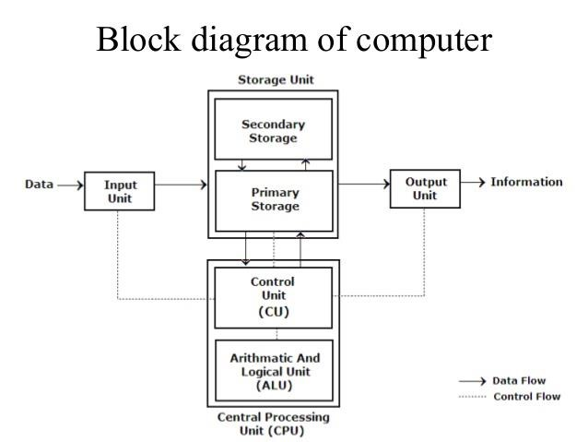

## Input unit: -

The source program/high level languages program/coded information/simply data is fed to a computer through input devices keyboard is a most common type. Whenever a key is pressed, one corresponding word or number is translated into its equivalent binary code over a cable & fed either to memory or processor. Joysticks, trackballs, mouse, scanners etc. are other input devices.

Memory unit: -

Its function into store programs and data. It is basically to two types

### 1. Primary memory 2. Secondary memory

**Word:**

In computer architecture, a word is a unit of data of a defined bit length that can be addressed and moved between [storage](http://searchstorage.techtarget.com/definition/storage) and the computer [processor.](http://searchcio-midmarket.techtarget.com/definition/processor) Usually, the defined bit length of a word is equivalent to the width of the computer's data bus so that a word can be moved in a single operation from storage to a processor [register.](http://whatis.techtarget.com/definition/register) For any computer architecture with an eight-bit [byte,](http://searchstorage.techtarget.com/definition/byte) the word will be some multiple of eight bits. In IBM's evolutionary System/360 architecture, a word is 32 bits, or four contiguous eight-bit bytes. In Intel's PC processor architecture, a word is 16 bits, or two contiguous eight-bit bytes. A word can contain a computer [instruction,](http://searchcio-midmarket.techtarget.com/definition/instruction) a storage address, or application data that is to be manipulated (for example, added to the data in another word space).

The number of bits in each word is known as word length. Word length refers to the number of bits processed by the CPU in one go. With modern general purpose computers, word size can be 16 **bits** to **64 bits**.

The time required to access one word is called the memory access time. The small, fast, RAM units are called caches. They are tightly coupled with the processor and are often contained on the same IC chip to achieve high performance.

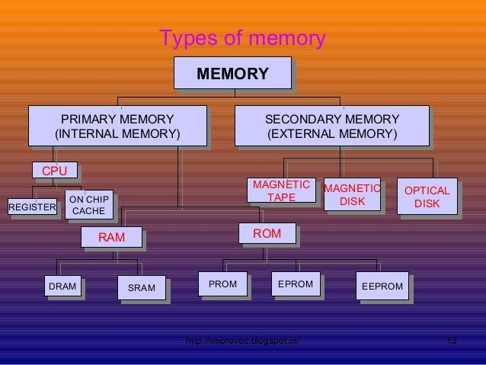

1. **Primary memory: -** Is the one exclusively associated with the processor and operatesat the electronics speeds programs must be stored in this memory while they are being executed. The memory contains a large number of semiconductors storage cells. Each capable of storing one bit of information. These are processed in a group of fixed site called word.

To provide easy access to a word in memory, a distinct address is associated with each word location. **Addresses are** numbers that identify memory location.

Number of bits in each word is called word length of the computer. Programs must reside in the memory during execution. Instructions and data can be written into the memory or read out under the control of processor. Memory in which any location can be reached in a short and fixed amount of time after specifying its address is called random access memory (RAM).

The time required to access one word in called memory access time. Memory which is only readable by the user and contents of which can’t be altered is called read only memory (ROM) it contains operating system.

Caches are the small fast RAM units, which are coupled with the processor and are often contained on the same IC chip to achieve high performance. Although primary storage is essential it tends to be expensive.

**2 Secondary Memory: -** Is used where large amounts of data & programs have to bestored, particularly information that is accessed infrequently.

**Examples: -** Magnetic disks & tapes, optical disks (ie CD-ROM’s), floppies etc.,

## Arithmetic logic unit (ALU):-

Most of the computer operators are executed in ALU of the processor like addition, subtraction, division, multiplication, etc. the operands are brought into the ALU from memory and stored in high speed storage elements called register. Then according to the instructions the operation is performed in the required sequence.

The control and the ALU are many times faster than other devices connected to a computer system. This enables a single processor to control a number of external devices such as key boards, displays, magnetic and optical disks, sensors and other mechanical controllers.

Output unit:-

These actually are the counterparts of input unit. Its basic function is to send the processed results to the outside world.

**Examples: -** Printer, speakers, monitor etc.

## Control unit:-

It effectively is the nerve center that sends signals to other units and senses their states. The actual timing signals that govern the transfer of data between input unit, processor, memory and output unit are generated by the control unit.

**Register:**

It is a special, high-speed storage area within the CPU. All data must be represented in a register before it can be processed. For example, if two numbers are to be multiplied, both numbers must be in registers, and the result is also placed in a register. (The register can contain the address of a memory location where data is stored rather than the actual data itself.)

The number of registers that a CPU has and the size of each (number of bits) help determine the power and speed of a CPU. For example a 32-bit CPU is one in which each register is 32 bits wide. Therefore, each CPU instruction can manipulate 32 bits of data. In high-level languages, the compiler is responsible for translating high-level operations into low-level operations that access registers.

Computer instructions are the basic components of a machine language program. They are also known as *macro operations*, since each one is comprised of sequences of micro operations.

Each instruction initiates a sequence of micro operations that fetch operands from registers or memory, possibly perform arithmetic, logic, or shift operations, and store results in registers or memory.

Instructions are encoded as binary *instruction codes*. Each instruction code contains of a *operation code*, or *opcode*, which designates the overall purpose of the instruction (e.g. add, subtract, move, input, etc.). The number of bits allocated for the opcode determined how many different instructions the architecture supports.

In addition to the opcode, many instructions also contain one or more *operands*, which indicate where in registers or memory the data required for the operation is located. For example, and add instruction requires two operands, and a not instruction requires one.

15 12 11 6 5 0

+-----------------------------------+

| Opcode | Operand | Operand |

+-----------------------------------+

The opcode and operands are most often encoded as unsigned binary numbers in order to minimize the number of bits used to store them. For example, a 4-bit opcode encoded as a binary number could represent up to 16 different operations.

The *control unit* is responsible for decoding the opcode and operand bits in the instruction register, and then generating the control signals necessary to drive all other hardware in the CPU to perform the sequence of micro operations that comprise the instruction.

**INSTRUCTION CYCLE:**

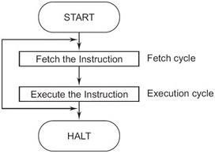

1. After the time required to access the memory elapses, the address word is read out of the memory and loaded into the MDR.
2. Now contents of MDR are transferred to the IR & now the instruction is ready to be decoded and executed.
3. If the instruction involves an operation by the ALU, it is necessary to obtain the required operands.
4. An operand in the memory is fetched by sending its address to MAR & Initiating a read cycle.
5. When the operand has been read from the memory to the MDR, it is transferred from MDR to the ALU.
6. After one or two such repeated cycles, the ALU can perform the desired operation.
7. If the result of this operation is to be stored in the memory, the result is sent to MDR.
8. Address of location where the result is stored is sent to MAR & a write cycle is initiated.
9. The contents of PC are incremented so that PC points to the next instruction that is to be executed.

Normal execution of a program may be preempted (temporarily interrupted) if some devices require urgent servicing, to do this one device raises an Interrupt signal. An interrupt is a request signal from an I/O device for service by the processor. The processor provides the requested service by executing an appropriate interrupt service routine.

The Diversion may change the internal stage of the processor its state must be saved in the memory location before interruption. When the interrupt-routine service is completed the state of the processor is restored so that the interrupted program may continue.

# **THE VON NEUMANN ARCHITECTURE**

Von-Neumann computer architecture design was proposed in 1945.It was later known as Von-Neumann architecture.

Historically there have been 2 types of Computers:

1. **Fixed Program Computers –** Their function is very specific and they couldn’t be reprogrammed, e.g. Calculators.
2. **Stored Program Computers –** These can be programmed to carry out many different tasks, applications are stored on them, hence the name.

Modern computers are based on a stored-program concept introduced by John Von Neumann. In this stored-program concept, programs and data are stored in the same memory. This novel idea meant that a computer built with this architecture would be much easier to reprogram.

The basic structure is like this,

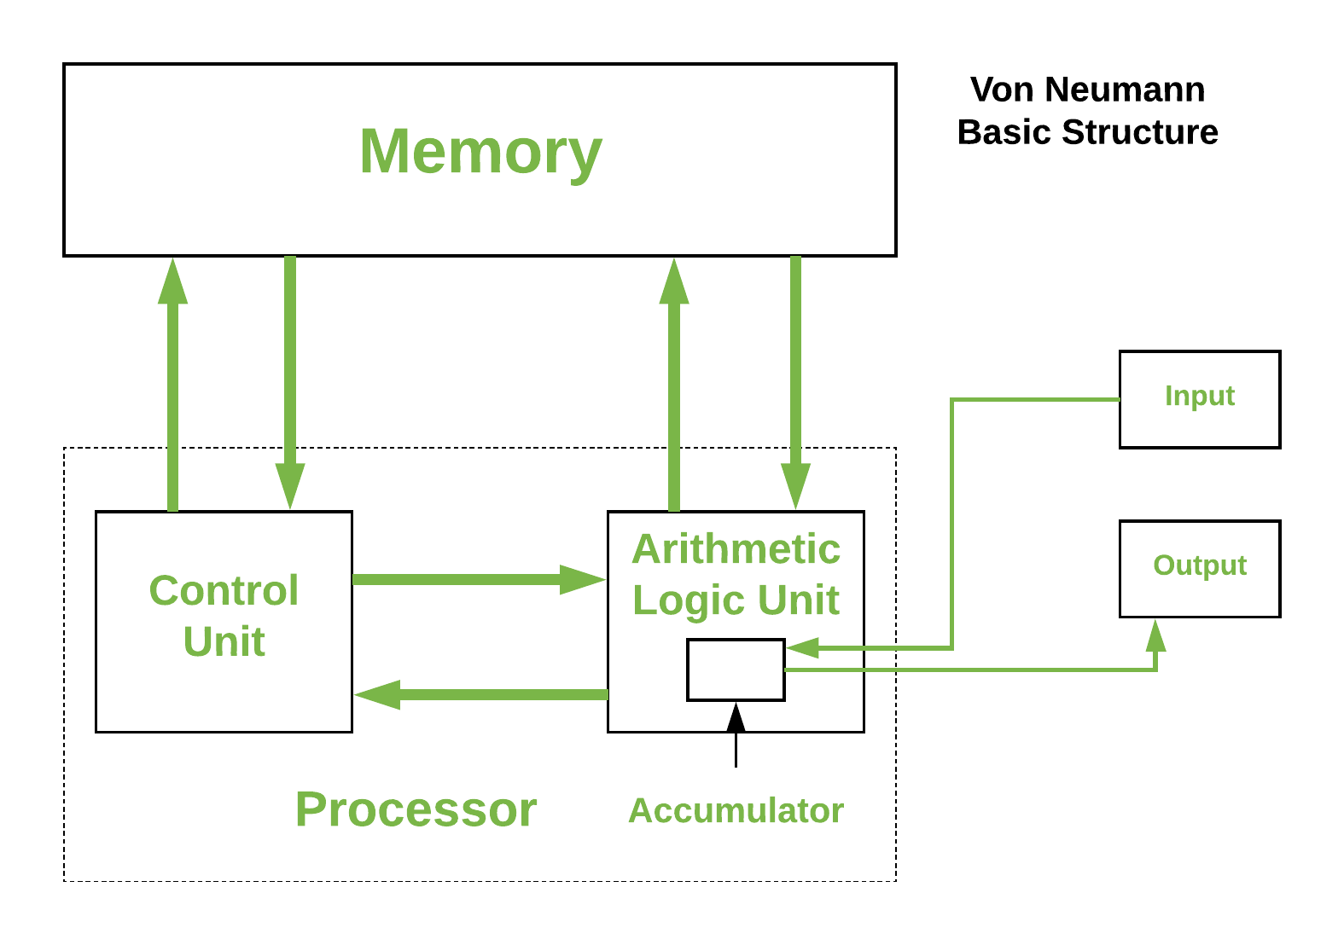

It is also known as **ISA**(Instruction set architecture) computer and is having three basic units:

1. The Central Processing Unit (CPU)
2. The Main Memory Unit
3. The Input/Output Device

**1. Central Processing Unit:**The central processing unit is defined as the it is an electric circuit used for the executing the instruction of computer program.

**It has following major components:**

**1 Control Unit(CU)**

**2 Arithmetic and Logic Unit(ALU)**

**3. Variety of Registers**

* **Control Unit –**   
  A control unit (CU) handles all processor control signals. It directs all input and output flow, fetches code for instructions, and controls how data moves around the system.
* **Arithmetic and Logic Unit (ALU) –**   
  The arithmetic logic unit is that part of the CPU that handles all the calculations the CPU may need, e.g. Addition, Subtraction, Comparisons. It performs Logical Operations, Bit Shifting Operations, and Arithmetic operations.

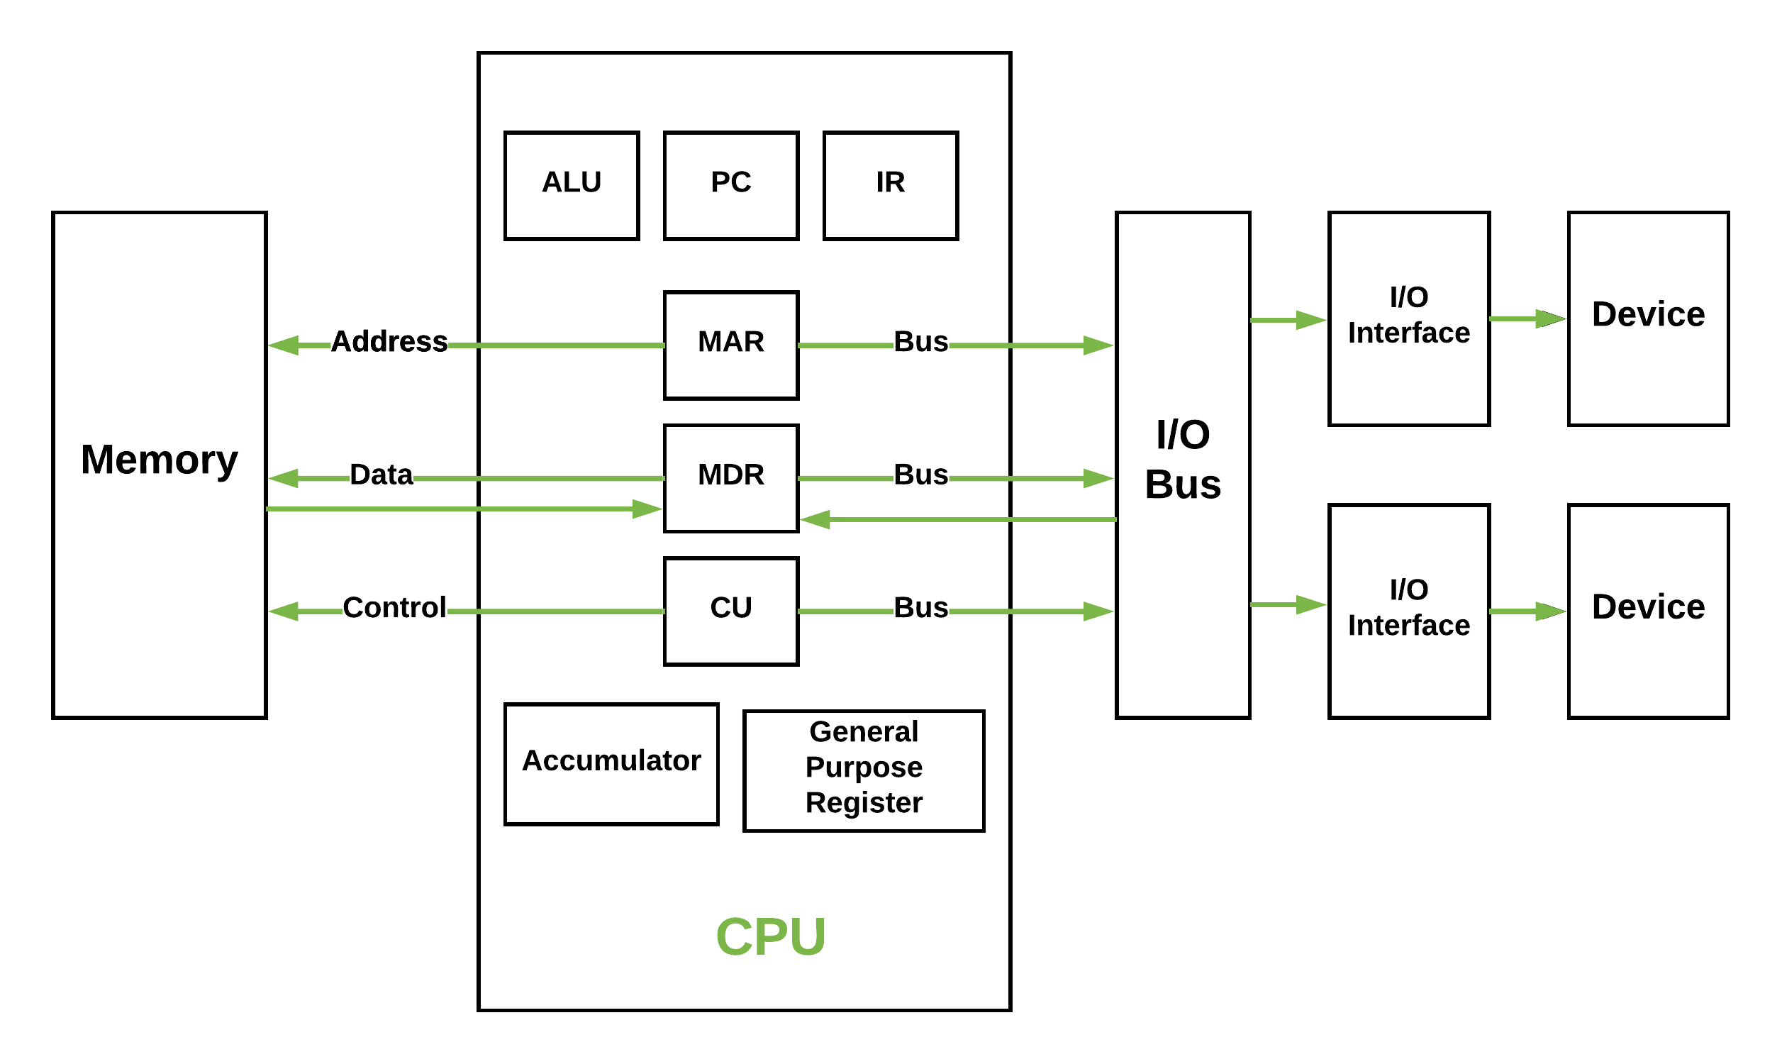

**Figure –** Basic CPU structure, illustrating ALU

* **Registers –** Registers refer to high-speed storage areas in the CPU. The data processed by the CPU are fetched from the registers. There are different types of registers used in architecture:-
  1. **Accumulator:** Stores the results of calculations made by ALU. It holds the intermediate of arithmetic and logical operatoins. it acts as a temporary storage location or device.
  2. **Program Counter (PC):** Keeps track of the memory location of the next instructions to be dealt with. The PC then passes this next address to the Memory Address Register (MAR).
  3. **Memory Address Register (MAR):** It stores the memory locations of instructions that need to be fetched from memory or stored in memory.
  4. **Memory Data Register (MDR):** It stores instructions fetched from memory or any data that is to be transferred to, and stored in, memory.
  5. **Current Instruction Register (CIR):** It stores the most recently fetched instructions while it is waiting to be coded and executed.
  6. **Instruction Buffer Register (IBR):** The instruction that is not to be executed immediately is placed in the instruction buffer register IBR.
* **Buses –** Data is transmitted from one part of a computer to another, connecting all major internal components to the CPU and memory, by the means of Buses. Types:
  1. **Data Bus:** It carries data among the memory unit, the I/O devices, and the processor.
  2. **Address Bus:** It carries the address of data (not the actual data) between memory and processor.
  3. **Control Bus:** It carries control commands from the CPU (and status signals from other devices) in order to control and coordinate all the activities within the computer**.**
* **Input/Output Devices –** Program or data is read into main memory from the *input device* or secondary storage under the control of CPU input instruction. *Output devices* are used to output information from a computer. If some results are evaluated by the computer and it is stored in the computer, then with the help of output devices, we can present them to the user.

**Von Neumann bottleneck –**

Whatever we do to enhance performance, we cannot get away from the fact that instructions can only be done one at a time and can only be carried out sequentially. Both of these factors hold back the competence of the CPU. This is commonly referred to as the ‘Von Neumann bottleneck’. We can provide a Von Neumann processor with more cache, more RAM, or faster components but if original gains are to be made in CPU performance, then an influential inspection needs to take place of CPU configuration.

This architecture is very important and is used in our PCs and even in Super Computers.

# **Software**

Software, which is abbreviated as SW or S/W, is a set of programs that enables the hardware to perform a specific task. All the programs that run the computer are software. The software can be of three types: system software, application software, and programming software.

## 1) System Software

The system software is the main software that runs the computer. When you turn on the computer, it activates the hardware and controls and coordinates their functioning. The application programs are also controlled by system software. An operating system is an example of system software.

### **i) Operating System:**

An operating system is the system software that works as an interface to enable the user to communicate with the computer. It manages and coordinates the functioning of hardware and software of the computer. The commonly used operating systems are Microsoft Windows, [Linux](https://www.javatpoint.com/linux-tutorial), and Apple Mac OS X.

**Some other examples of system software include:**

* **BIOS:** It stands for basic input output system. It is a type of system software, which is stored in Read Only Memory (ROM) located on the motherboard. However, in advanced computer systems, it is stored in flash memory. BIOS is the first software that gets activated when you turn on your computer system. It loads the drivers of the hard disk into memory as well as assists the operating system to load itself into the memory.
* **Boot Program:** Boot refers to starting up a computer. When you switch on the computer, the commands in the ROM are executed automatically to load the boot program into memory and execute its instructions. The BIOS program has a basic set of commands that enables the computer to perform the basic input/output instructions to start the computer.
* **An assembler:** It plays the role of a converter as it receives basic computer instructions and converts them into a pattern of bits. The processor uses these bits to perform basic operations.
* **A device driver:** This system software controls hardware devices connected to a computer. It enables the computer to use the hardware by providing an appropriate interface. The kernel of a Computer's CPU communicates with different hardware through this software. Operating systems generally come with most of the device drivers. If the operating system does not have a device driver for hardware, you have to install the device driver before using that hardware device.

## 2) Application Software:

Application software is a set of programs designed to perform a specific task. It does not control the working of a computer as it is designed for end-users. A computer can run without application software. Application software can be easily installed or uninstalled as required. It can be a single program or a collection of small programs. Microsoft Office Suite, Adobe Photoshop, and any other software like payroll software or income tax software are application software. As we know, they are designed to perform specific tasks. Accordingly, they can be of different types such as:

* **Word Processing Software:** This software allows users to create, edit, format, and manipulate the text and more. It offers lots of options for writing documents, creating images, and more. For example, MS Word, WordPad, Notepad, etc.
* **Spreadsheet Software:** It is designed to perform calculations, store data, create charts, etc. It has rows and columns, and the data is entered in the cell, which is an intersection of a row and column, e.g., Microsoft Excel.
* **Multimedia Software:** This software is developed to perform editing of video, audio, and text. It allows you to combine texts, videos, audio, and images. Thus, you can improve a text document by adding photos, animations, graphics, and charts through multimedia software. For example, VLC player, Window Media Player, etc.
* **Enterprise Software:** This software is developed for business operational functions. It is used in large organizations where the quantum of business is too large. It can be used for accounting, billing, order processing and more. For example, CRM (Customer Relationship Management), BI (Business Intelligence), ERP (Enterprise Resource Planning), SCM (Supply Chain Management), customer support system, and more.

## 3) Programming Software:

It is a set or collection of tools that help developers in writing other software or programs. It assists them in creating, debugging, and maintaining software or programs or applications. We can say that these are facilitator software that helps translate programming language such as [Java](https://www.javatpoint.com/java-tutorial), [C++](https://www.javatpoint.com/cpp-tutorial), [Python](https://www.javatpoint.com/python-tutorial), etc., into machine language code. So, it is not used by end-users. For example, compilers, linkers, debuggers, interpreters, text editors, etc. This software is also called a programming tool or software development tool.

Some examples of programming software include:

* **Eclipse:** It is a java language editor.
* **Coda:** It is a programming language editor for Mac.
* **Notepad++:** It is an open-source editor for windows.
* **Sublime text:** It is a cross-platform code editor for Linux, Mac, and Windows.